# Exercises: HTML Structure

Problems for exercises and homework for the “HTML and CSS” course @ SoftUni. Submit your solutions in the SoftUni judge system at <https://judge.softuni.bg/Contests/396/HTML-Structure>.

## Simple Navigation Bar

Create a Web Page like the following:

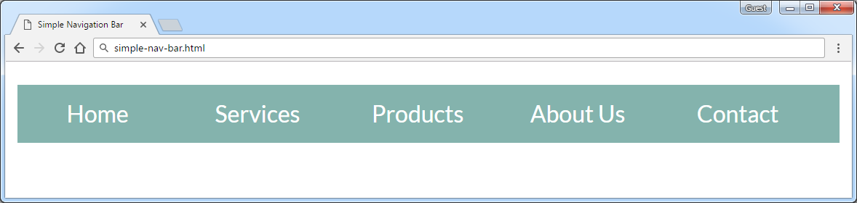

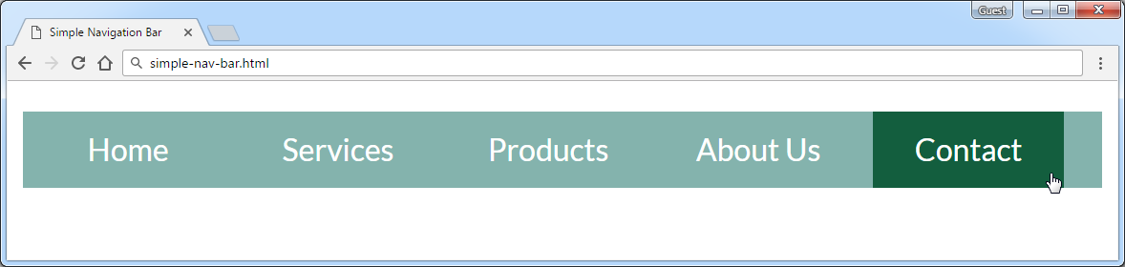

Create two files: "**simple-nav-bar.html**" and "**simple-nav-bar.css**".

### Constraints

* <body>
  + **font-family: "Lato", sans-serif;**
* <nav>tag as container
* Use unordered list in the navigation section
  + Padding 0
  + Heigth 40px
  + Line Heigth 30px
  + Background Color #84b3ad
* <li> tag for list item
  + Width 100px
  + Margin 0 5px
  + Padding 5px 0
  + Cursor **pointer**
  + Text color #ffffff
  + Center the text
* <li>on hover
  + Background Color #135e3e
  + Padding 5px 0
* Put a **hyperlink** in each list item in the navigation bar.
* Remove the text decoration and fix its color:
  + Put “text-decoration: none” for the “li a” CSS selector.
  + Change the color for the “li a” CSS selector.

### Hints

* <li> with display:inline-block;in the CSS file
* Put in your CSS all @font-face definitions from <https://fonts.googleapis.com/css?family=Lato:300,400,900>

Your **HTML** file might look like this:

|  |
| --- |
| **simple-nav-bar.html** |
| <!DOCTYPE html> <**html**> <**head**>  <**title**>Simple Navigation Bar</**title**>  <**link rel="stylesheet" href="simple-nav-bar.css"**> </**head**> <**body**>  **<nav>  <ul>**  **<li><a href="#">**Home**</a></li>  *<--TODO: put the rest of list item here -->***  **</ul>  </nav>** **</body> </html>** |

Your **CSS** file might look like this:

|  |
| --- |
| **simple-nav-bar.css** |
| **@font-face** … *(include the code from* [*https://fonts.googleapis.com/css?family=Lato:300,400,900*](https://fonts.googleapis.com/css?family=Lato:300,400,900)*)*  **body** { // TODO }  **ul** { // TODO }  **li** { // TODO }  **li a** { // TODO }  **li:hover** { // TODO } |

## Simple Article

Create a Web Page like the screenshot below using the text from the file "**article.txt**".

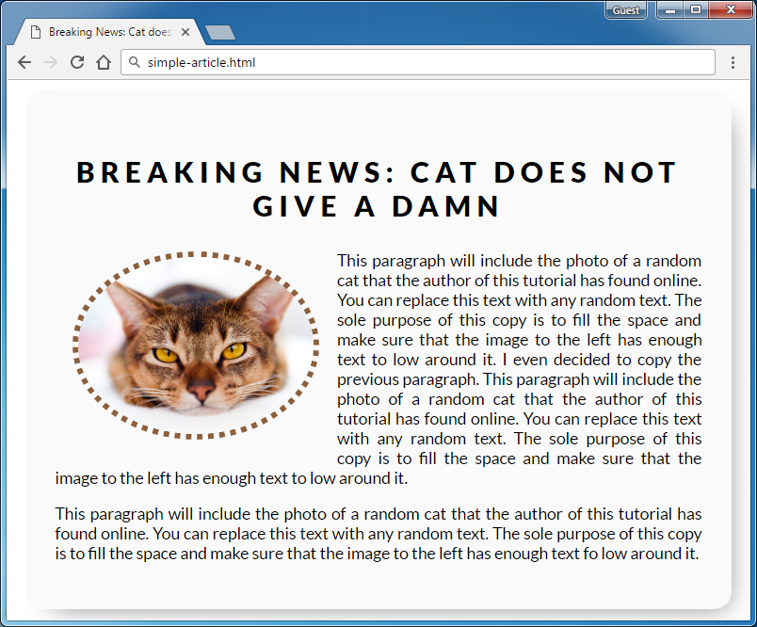

Create two files: "**simple-article.html"** and **"simple-article.css"**

Use **semantic HTML** to create HTML the page.

### Constraints

* <body>
  + font-family:"Lato", sans-serif;[**"https://fonts.googleapis.com/css?family=Lato:300,400,900"**](https://fonts.googleapis.com/css?family=Lato:300,400,900)
* Content
  + Width 550px
  + Border radius15px
  + Center the content
  + Padding 25px
  + Background color #fafafa
  + box-shadow: 10px 11px 35px -14px rgba(0,0,0,0.54)
* <h1> tag for heading
  + Margin bottom 0
  + Padding 10px
  + Text center
  + Letter spacing 5px
* **Image**
  + Width 200px
  + Border radius 50%
  + Margin 15px
  + Border 5px dotted #8b603d
  + Use “**left floating**” for the image: <https://css-tricks.com/almanac/properties/f/float/>
* **Paragraphs**
  + Text size 14px
  + Use “text-align: justify” to align the text left and right (learn more at <http://www.w3schools.com/css/css_text.asp>).

## Create Header

Create a Web Page like the screenshot below:





Create two files: "**create-header.html**"and"**create-header.css**"

Use **semantic HTML** to create the HTML page.

### Constraints

* <body>
  + Font-family "Lato", sans-serif
  + Text color #ffffff
* <header>with **class="container"**
  + Center the container
  + Padding 0 10px
  + Backgroundurl(background-image.jpg) no-repeat center center
  + Background size cover
  + Height 800px
  + Text center
* <h1>for heading
  + Text size 80px
  + Padding 80px 0
  + Letter spacing 8px
  + Transform the heading text to **uppercase** with CSS (see <http://www.w3schools.com/cssref/pr_text_text-transform.asp>).
* Paragraphfor the text
  + Text size 27px
  + Font weigth 100
  + Margin 20px
  + Escape the quotes using &quot;
* <button>with class **btn** for button
  + Text color #ffffff
  + Background none
  + Border 5px solid #ffffff
  + Border radius 15px
  + Padding 15px 45px
  + Text size 16px
* **Button** on hover
  + Background #000
  + Border color #000
  + Cursor **pointer**

### Hints

Reset the CSS margins and paddings, like it is explained here: <https://css-tricks.com/reset-all-margins-padding/>.

## Create Content

Create a Web Page like the following using the text from “create-content.txt”.

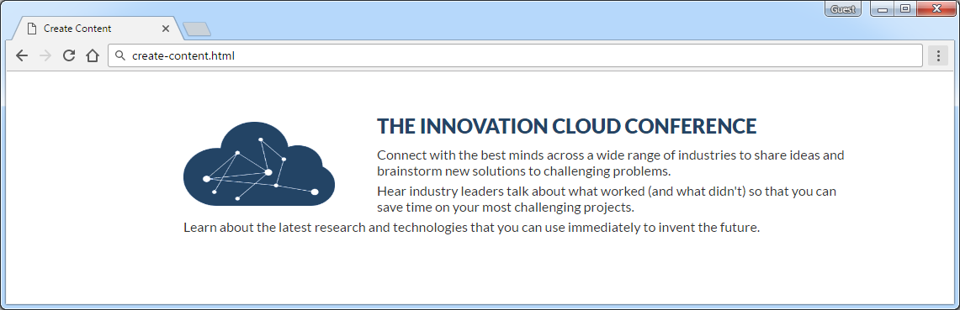

Create two files: "**create-content.html**" and "**create-content.css**"

### Constraints

* Font-family "Lato", sans-serif
* <main>as a **container**
  + Margin 50px auto
  + Max width 1060px
  + Padding 0 10px
* <h2>for heading
  + Text color #234465
  + Margin 10px
* Paragraph
  + Text size 16px
  + Text color #333333
  + Margin bottom5px
  + Letter spacing 0
  + Width800px
* Image
  + Align the image on the left side.
  + Width 180px
  + Height 100px
  + Margin 10px 50px 0 0

## Innovation Cloud

* Create a Web Page like the following.

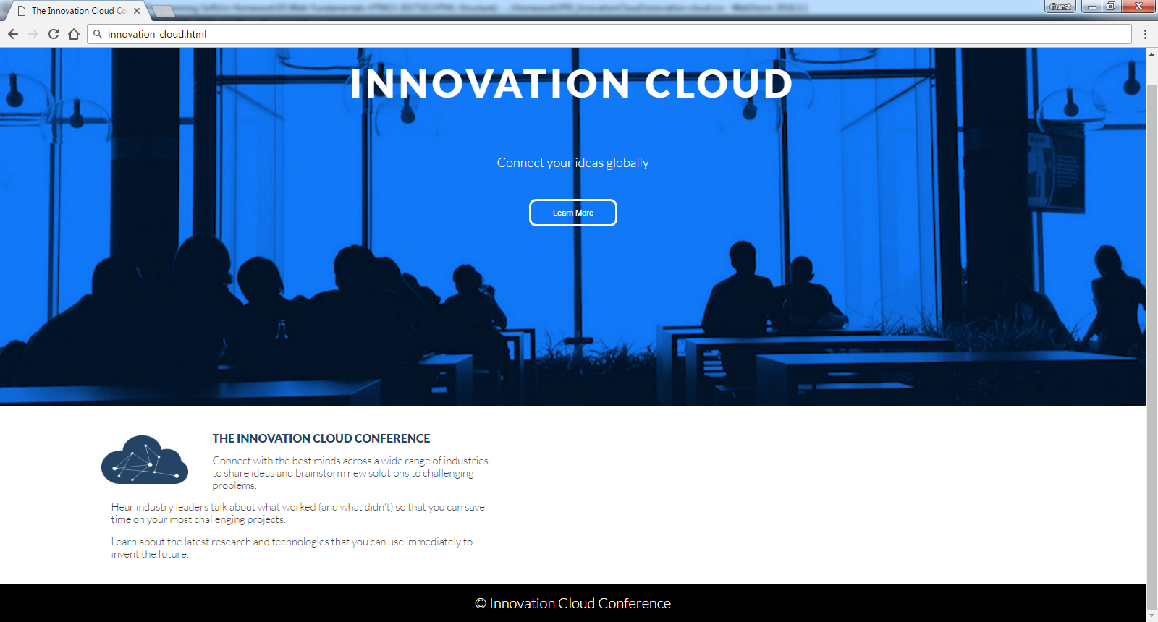

Create two files: "**innovation-cloud.html**"and "**innovation-cloud.css**"

Use **Semantic HTML** to create the page

### Constraints

* **Problem 3 + Problem 4**
* **Footer**
  + **Background color: #000000**
* Text in the footer
  + Text color: **#ffffff**
  + Text size: **14px;**
  + Height: **80px;**
  + Line height: **80px;**
  + Margin: **0px;**
  + Use the **HTML entity** for the “Copyright” character “**©**”.

## *Conference

Create a Web Page like the following using **conference.txt**

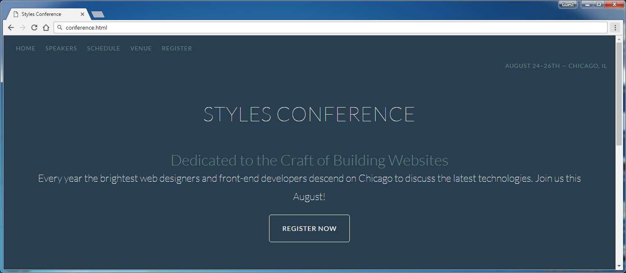

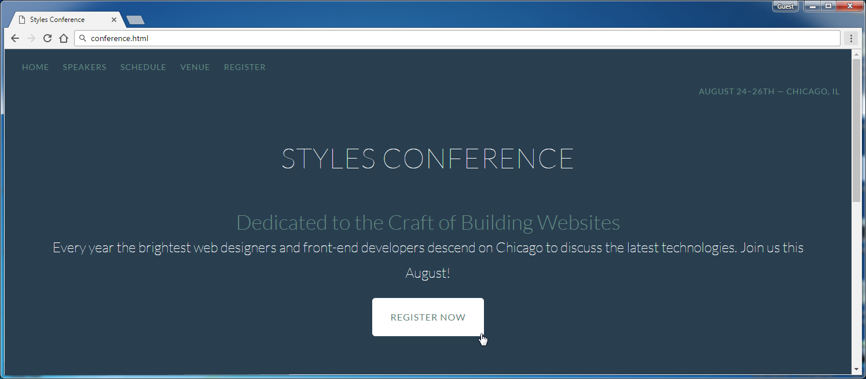





Create two files: "**conference.html**" and "**conference.css**"

Use **semantic HTML** to create the HTML page.

### Hints

* You may use **color picker** software ([search in Google](https://www.google.bg/search?q=color+picker+software)) to select the color of certain screen pixel.
* Use a hyperlink for the **button**.
* Get the “Lato” font from: <http://fonts.googleapis.com/css?family=Lato:100,300,400>.
* Default font: **300 16px/22px "Lato", sans-serif**

## Table

Create a Web Page like the following using the text from the file “table.txt”.

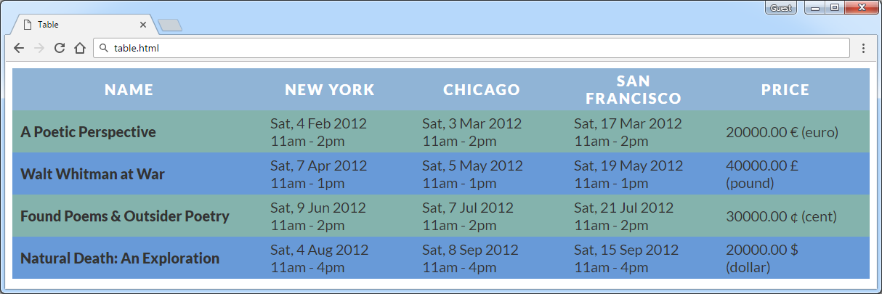

Create two files: "**table.html**" and "**table.css**".

Use **semantic HTML** to create the page.

### Constraints

* Font-family "Lato", sans-serif
* Table
  + Text color #333333
  + Border spacing none
  + Center the **table**
* Table headings
  + Text color #ffffff
  + Background color #90b4d6
  + Center the text
  + Letter spacing 2px
* Table headingfor bold text
  + Padding 5px 30px 5px 10px
  + Text size 18px
  + Margin 0
  + Text align **left**
  + Background color #84b3ad
* Table data
  + Padding 5px 30px 5px 10px
  + Text size 18px
  + Margin 0
  + Text align **left**
  + Background color #84b3ad
  + Width 150px

### Hints

Use:

* **tr:nth-child(even) td, tr:nth-child(even) th** { Background color **#689ad8**

}

* Search search in Internet for the **HTML entities** representing the currency symbols: <https://www.google.bg/search?q=html+entities+currency+symbols>.

## Book Store

Create a Web Page like the following using the texts from “**book-store.txt**”.

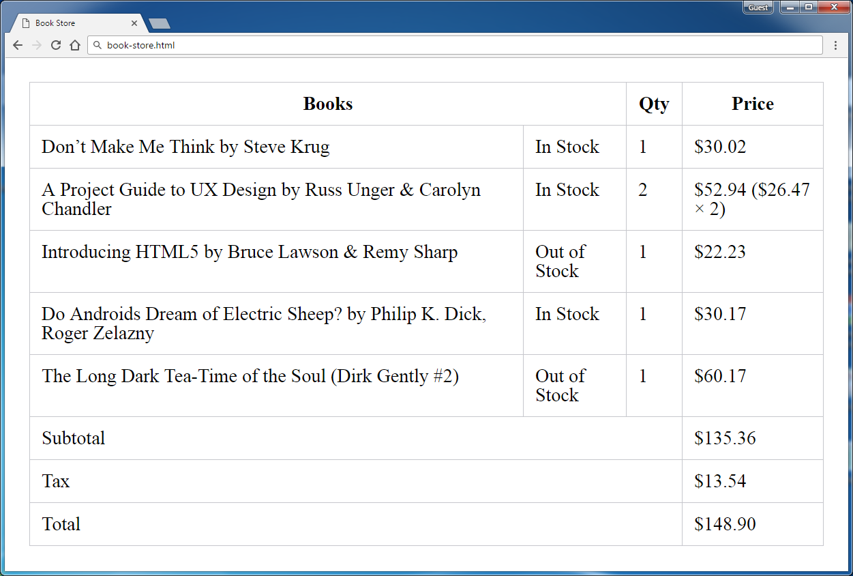

Create two files: "**book-store.html**" and "**book-store.css**".

### Constraints

* **Merge columns** in several table rows by using “colspan”.
* Table border color: #c6c7cc.
* Apply **padding** for all **table cells**.
* **Collapse** table borders to remove the empty space between the cells: <https://css-tricks.com/almanac/properties/b/border-collapse/>.

### Hints

Use:

* First reset the CSS styles.
* Use **&#8217;** for the **apostrophe**.
* Search Internet for **currency symbol HTML entiities** and other special symbols like **&**.